**PS3 Report**

蒲东川 12049029

1、

1.1 Unseeded Days data has a small precipitation and degree of dispersion, but Seeded Days data has a large degree of dispersion

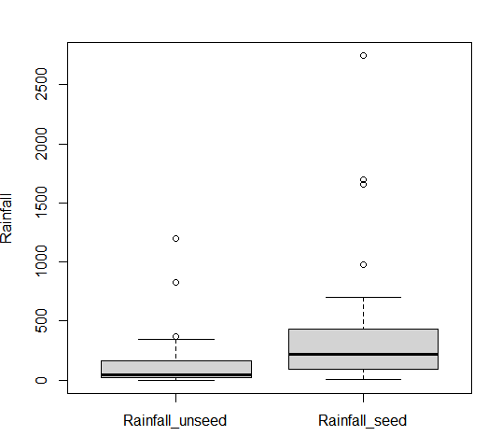

1.2

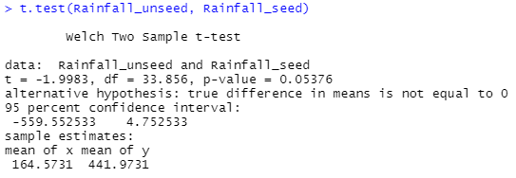

It shows that the difference between the two mean values is not significant. In this experiment, it is impossible to prove that seeding has an effect on precipitation.

2、

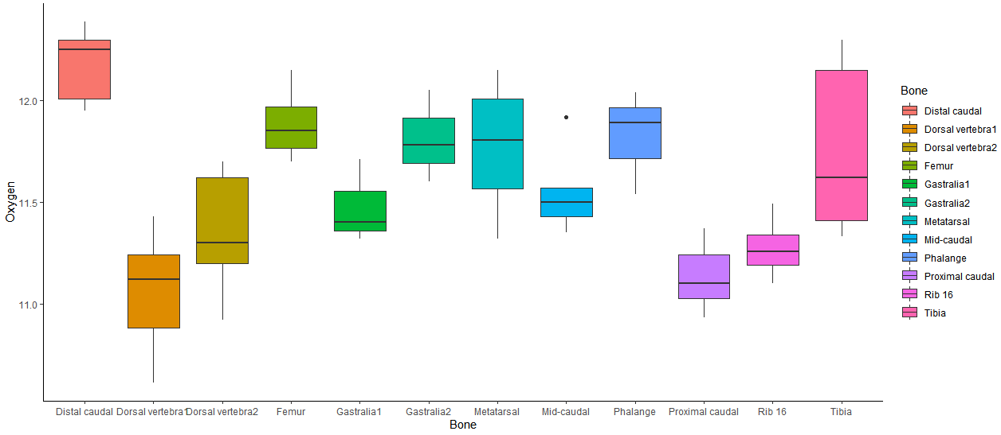

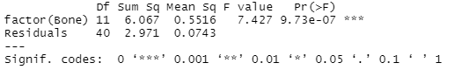

p-value < 0.05，There are differences in the average value of each bone sample of dinosaurs, indicating that Tyrannosaurus is not a warm-blooded animal

3、

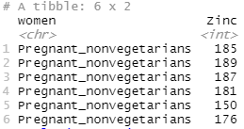

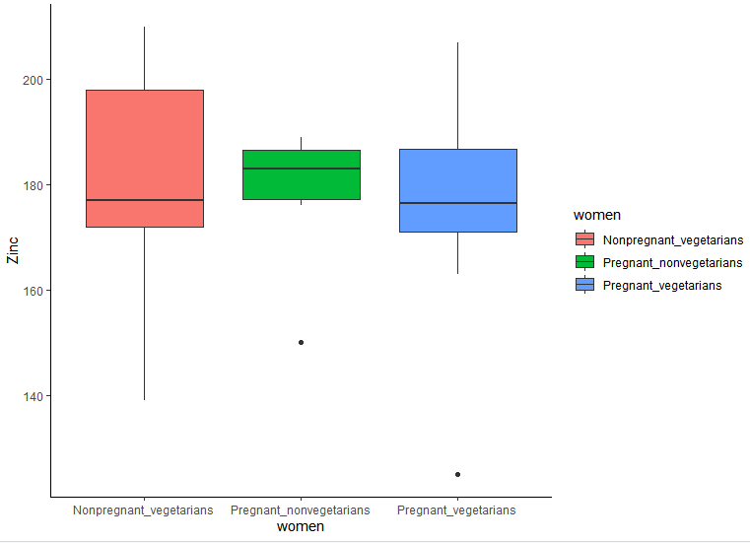

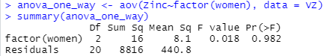

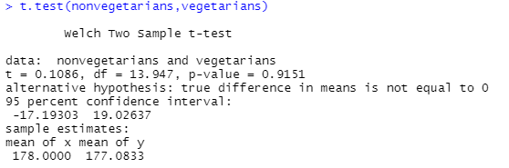

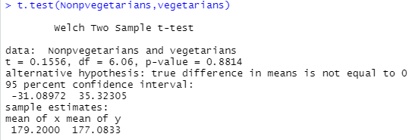

Through multiple tests, p-value>0.05, it can be considered that there is no significant difference in Zn content between pregnant non-vegetarian and pregnant vegetarian women.

4、

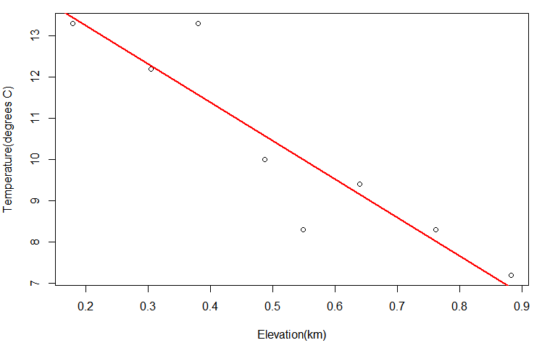

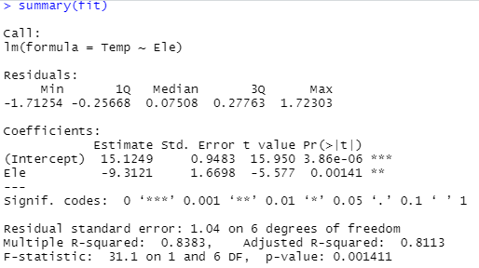

lapse rate:9.3121 degrees C km-1

5

5.1 The faster the recession velocity of the nebula, the farther away from the earth

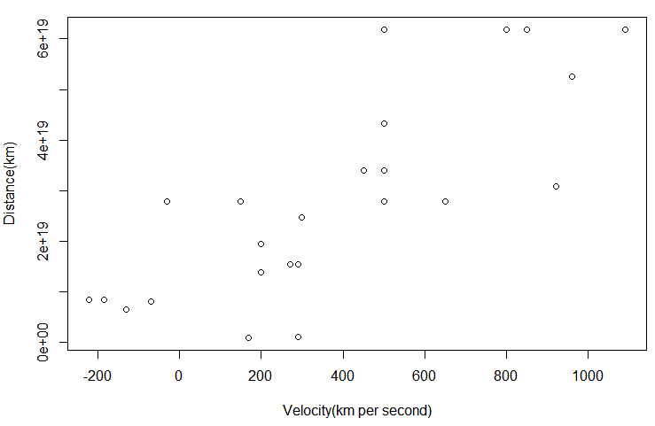

5.2

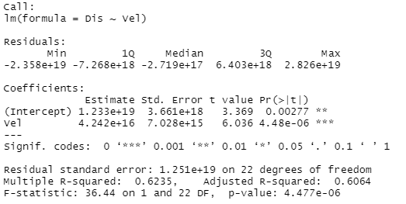

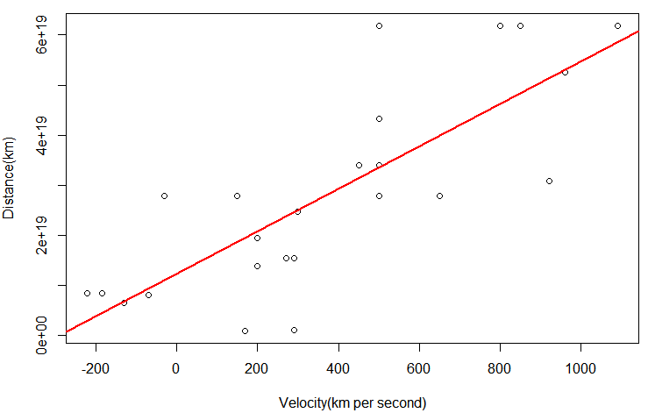

5.3 After linear regression, the slope of the curve is 5.938*1016(s), The age of the universe is 5.938*1016 s(1882016779 year)

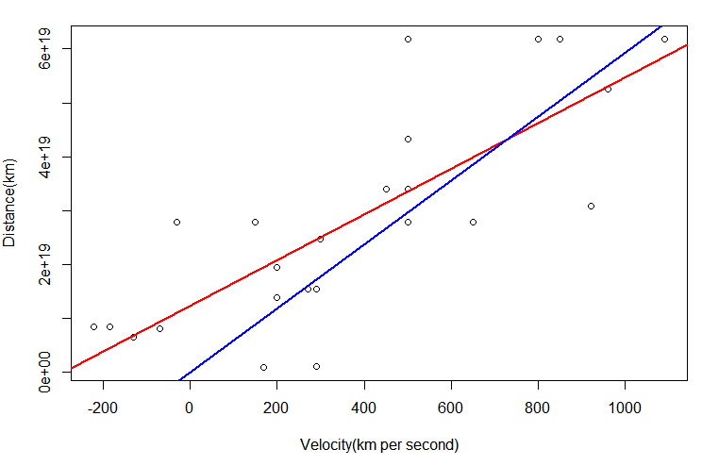

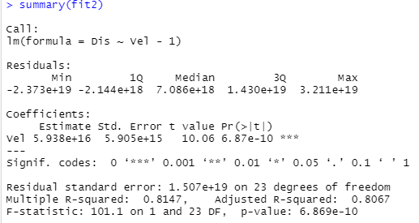

5.4 Because of the actual constraints added.

6、

6.1

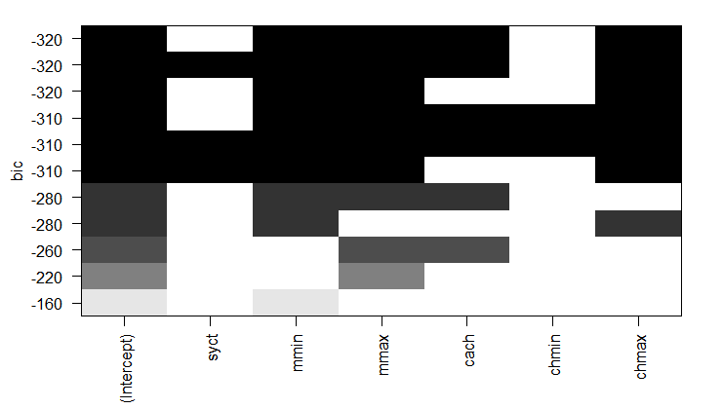

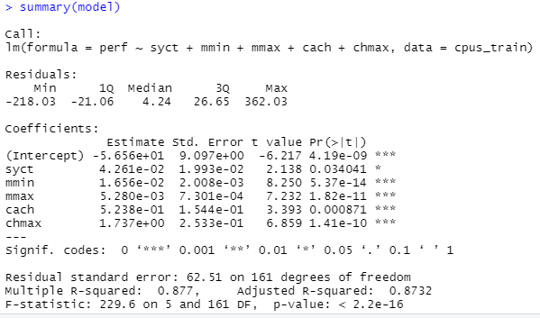

6.2

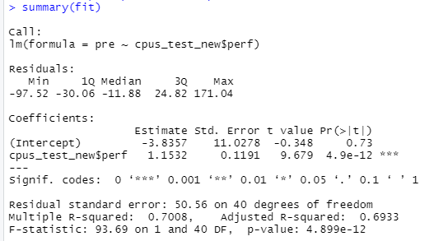

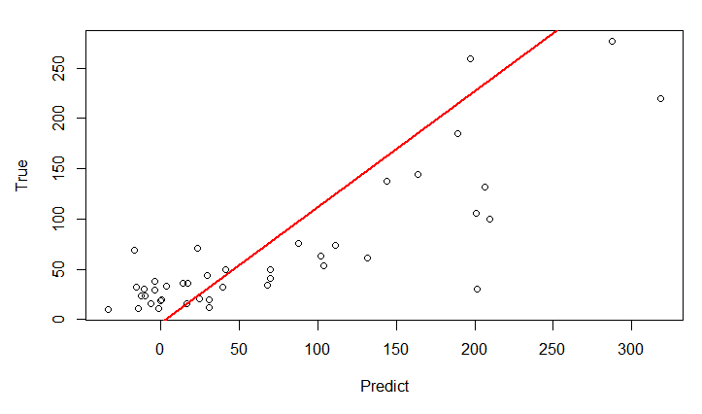



the mean bias between predicted perf values and provided perf values is 7.83

7、

7.1 Select the InsectSprays data from R,which shows the number of insects when using different insecticides.

Q: Is there a significant difference between A and B insecticides?

p-value>0.05, it can be considered that there is no significant difference between pregnant A and B insecticides.

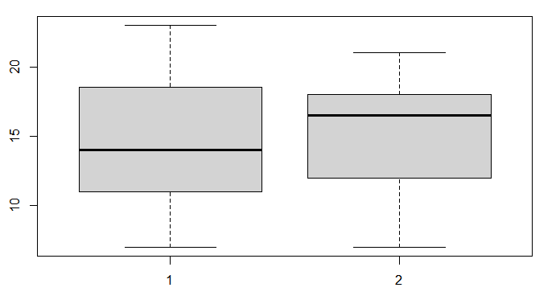

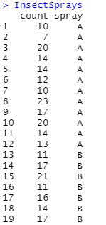

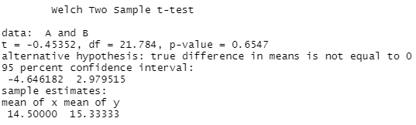

7.2

Q:Are there any significant differences in all types of pesticides?

p-value<0.05, it can be considered that there is significant difference in all types of pesticides.

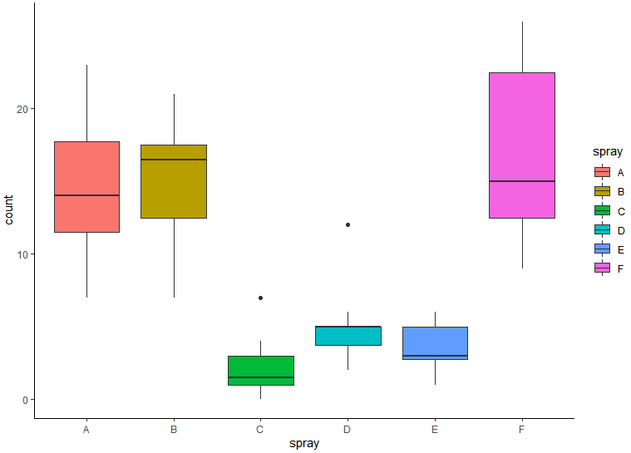

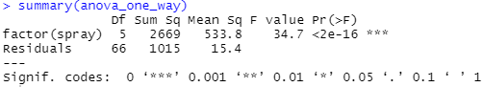

7.3

Q:What is the trend of lighting brightness at night in China

China night light brightness shows an increasing trend

